Nama : Awaliyah Hayatun

NIM : 221511010

Kelas : K2

Mata Kulia : Pemrograman Berorientasi Objek Lanjut

Link Praktikum-1 PBO2 2023 : <https://github.com/awaliyahhayatun/pemrograman_berorientasi_objek/tree/main/Praktikum-1%20PBO2%202023>

1. Celcius_Pro

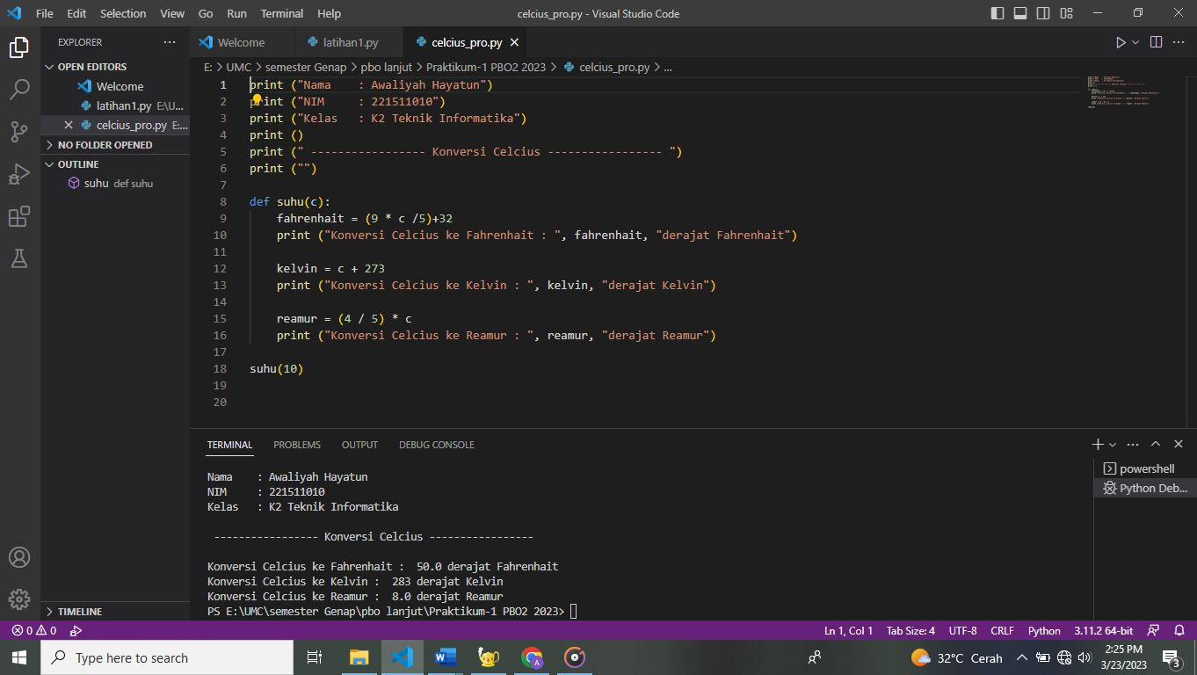

Script :

print ("Nama    : Awaliyah Hayatun")

print ("NIM     : 221511010")

print ("Kelas   : K2 Teknik Informatika")

print ()

print (" ----------------- Konversi Celcius ----------------- ")

print ("")

def suhu(c):

    fahrenhait = (9 * c /5)+32

    print ("Konversi Celcius ke Fahrenhait : ", fahrenhait, "derajat Fahrenhait")

    kelvin = c + 273

    print ("Konversi Celcius ke Kelvin : ", kelvin, "derajat Kelvin")

    reamur = (4 / 5) * c

    print ("Konversi Celcius ke Reamur : ", reamur, "derajat Reamur")

suhu(10)

1. Celcius_OOP

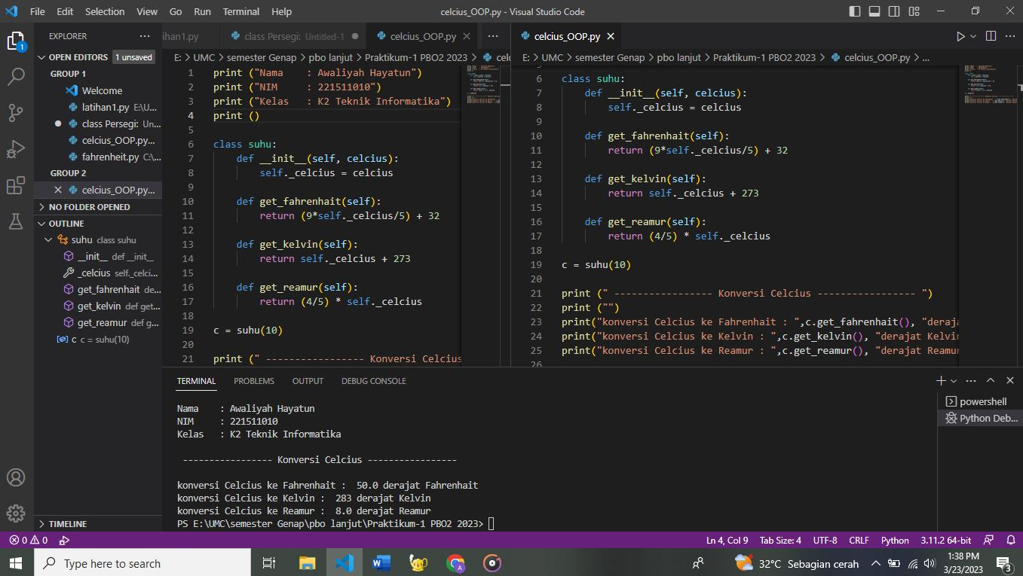

Script :

print ("Nama    : Awaliyah Hayatun")

print ("NIM     : 221511010")

print ("Kelas   : K2 Teknik Informatika")

print ()

class suhu:

    def __init__(self, celcius):

        self._celcius = celcius

    def get_fahrenhait(self):

        return (9*self._celcius/5) + 32

    def get_kelvin(self):

        return self._celcius + 273

    def get_reamur(self):

        return (4/5) * self._celcius

c = suhu(10)

print (" ----------------- Konversi Celcius ----------------- ")

print ("")

print("konversi Celcius ke Fahrenhait : ",c.get_fahrenhait(), "derajat Fahrenhait")

print("konversi Celcius ke Kelvin : ",c.get_kelvin(), "derajat Kelvin")

print("konversi Celcius ke Reamur : ",c.get_reamur(), "derajat Reamur")